**Procedure for Standardisation of an Infracont XGrain and SGrain.**

1. **Introduction**

What is Standardisation and why do we do it?

Standardisation of all instruments which are Full Members of the UK Grain Testing Network is a vital part of maintaining the network. Without it, individual instruments will drift away from the rest of the population and over time this will result in inaccurate results across the industry.

Prior to each harvest a set of standardisation samples is sent out to all full members of the network. Everyone receives an identical set of samples and is asked to scan them at the same time, this is to minimize any differences in scans due to sample ageing. We strongly recommend that scans are carried out after your annual NIR service rather than before as servicing may introduce biases which standardisation should correct.

The scans are used to adjust every instrument in the network to read as closely as possible to the sub-master instruments at Sciantec (wheat, barley, oats, bean sub-master) and Sharnbrook Grain (OSR sub-master). At the same time, the sub-master results are compared with the reference analyses and the committee and Infracont together decide on whether any changes to calibrations are required to ensure the best agreement between reference and NIR results.

If Infracont does not receive standardisation scans from you then your instrument cannot be adjusted to bring it into line with the sub-master, it cannot have any new calibration biases applied to it to keep it in agreement with the reference and it may result in your company being listed as not being up to date on the UKGTN website. With this in mind it is in your interest to ensure that you do everything you can to make sure that the scan collection exercise is carried out effectively on your instrument.

1. **Scanning samples**

Each year at standardisation time (May) you will be sent a set of standardisation samples and an email containing details of when these should be scanned.

Arrange the samples in numerical order starting with Barley, then Wheat, Rapeseed, Oats and Beans. You should have a set of samples for each commodity for which you have signed up with the network. If there are any missing or damaged contact Sciantec immediately so that we can send replacements in time to meet the scanning deadline.

Carry out the scan collection as follows:

1. **Standardisation Instructions – Infracont XGrain or Infracont SGrain**
2. **Delete the historic results** from the memory of the instrument before scanning of the standardization samples. (Results menu / ‘Delete results’)
3. Turn on **every component** of the product, except the Spectrum component.
   1. Barley samples must scanned on the “WINTER BARLEY” product, regardless of their subtype.
4. Scan the samples in **numerical order** starting with the sample with the lowest number:
   1. it is very important to key in the exact sample ID written on the bag, so please **add** the **sample ID** for every sample, so that each result in the instrument is clearly identifiable.
   2. Samples should be **scanned twice right after each other** using exactly the same sample ID. Obtaining duplicate scans will improve the effectiveness of the standardisation process.
5. Once scanning is complete, ensure all the **bags are sealed** and placed back into their box then store this in a cool, dark location in case rescanning is required in the future.
6. **Collection of data**

When all samples have been scanned, **connect** the instrument **to Internet** via Ethernet cable or Wi-Fi and **let Infracont know** (send e-mail to [UKGTN@infracont.com](mailto:UKGTN@infracont.com)), that the scans are ready for download.

**Follow Up:** What happens next?

Infracont downloads the spectral data and the results from the instruments. At this point Infracont may ask that some samples be scanned again if the scans seem unusual. The main reasons for this are usually running the samples in the wrong order, giving them wrong sample IDs, or missing out individual samples or whole commodities. Again, we will attempt to contact users to ask for rescans. These need to be carried out quickly if the data is to be used.

Once the agreed scanning date has passed, Infracont provides a list to the Grain Network of all instruments which have not reached. We then attempt to contact users of these instruments to find out why and encourage them to do whatever is required to get the results to Infracont.

Once the data is processed each instrument can be biased to match the results from the sub-masters and any calibration biases added. New calibrations are produced in approximately 2-4 weeks.

1. **Calibration Download**

Infracont will administrate on the [Infracont website](https://www.infracont.com/en/UKGTN) when the new calibrations are ready to be uploaded to the instruments.

When the new calibrations are installed on the instrument, the instrument will display this system message:

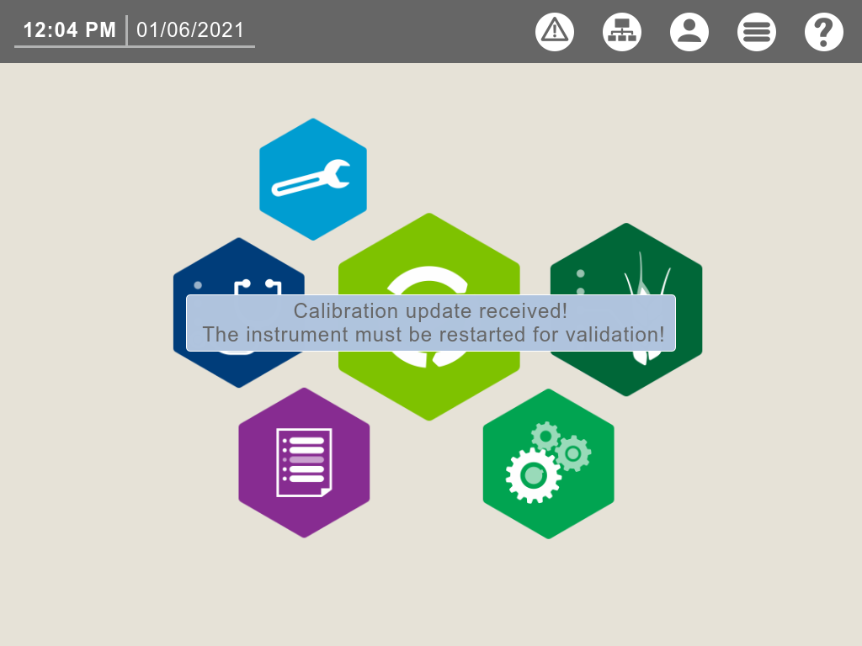

The new calibrations will be active after restart.

The list of the actual UKGTN calibrations are available on the [Infracont website](https://www.infracont.com/en/UKGTN).

Infracont provides a list to the Grain Network of all instruments which have not picked new calibrations up and we contact users to try and help remedy this.

Following calibration update all instruments should read within tolerance of the sub-master instrument. Performance of this instrument is monitored throughout harvest using new crop samples and if further bias corrections are required the calibration update procedure will be repeated.

To ensure no gross errors have been introduced during standardisation and calibration download we run a ‘quick check’ in place of a June Ring check round to compare results before and after standardisation on the April / May ring check samples.