

**Procedure for Standardisation of an Infratec 1241, Infratec NOVA or Infratec TM.**

**Introduction:** What is Standardisation and why do we do it?

Standardisation of all instruments which are Full Members of the UK Grain Testing Network is a vital part of maintaining the network. Without it, individual instruments will drift away from the rest of the population and over time this will result in inaccurate results across the industry.

Prior to each harvest a set of standardisation samples is sent out to all full members of the network. Everyone receives an identical set of samples and is asked to scan them at the same time, this is to minimize any differences in scans due to sample ageing. We strongly recommend that scans are carried out after your annual NIR service rather than before as servicing may introduce biases which standardisation should correct.

The scans are used to adjust every instrument in the network to read as closely as possible to the sub-master instruments at Sciantec and Sharnbrook Grain. At the same time, the sub-master results are compared with the reference analyses and the committee and Foss together decide on whether any changes to calibrations are required to ensure the best agreement between reference and NIR results.

If Foss do not receive standardisation scans from you then your instrument cannot be adjusted to bring it into line with the sub-master, it cannot have any new calibration biases applied to it to keep it in agreement with the reference and it may result in your company being listed as not being up to date on the UKGTN website. With this in mind it is in your interest to ensure that you do everything you can to make sure that the scan collection exercise is carried out effectively on your instrument.

**Scanning samples**

Each year at standardisation time (May) you will be sent a set of standardisation samples, an email containing details of when these should be scanned and the file names you should use. This email will also tell you the date at which scan upload will occur.

Arrange the samples in numerical order starting with Barley, then Wheat, Rapeseed, Oats and Beans. You should have a set of samples for each commodity for which you have signed up with the network. If there are any missing or damaged contact Sciantec immediately so that we can send replacements in time to meet the upload deadline.

Carry out the scan collection as follows:

**Standardisation Instructions - Infratec 1241:**

Note: If you have a 1241 with a USB socket at the front, follow the *(USB)* instructions, if you have a floppy drive follow the *(Floppy)* instructions. Most steps are identical.

***(USB)***

1. Press the ‘Menu’ button or task bar.
2. Press 6 and use the ‘enter’ key to toggle ‘Save Scans’ to ‘On’
3. Press 7 and use the ‘enter’ key to toggle ‘Save Results’ to ‘On’
4. Press ‘Menu’ to return to main operators menu
5. Use the TAB or select AM key to select the correct Application Model for scanning.

***(Floppy)***

1. Press task bar button .
2. Ensure the ‘save scans’ icon is not crossed. The icon is 3rd from left and looks like a graph / spectra. If it has a cross over it use the arrow keys to move the cursor and the enter key to toggle the cross off.
3. Ensure the ‘save results’ icon is not crossed. The icon is 4th from left and looks like grain and a small floppy disk. If it has a cross over it use arrow keys to move the cursor and the enter to toggle the cross off.
4. When set correctly if you wait a minute or so the instrument will return to normal operators menu.
5. With up and down arrows select the Application Model you wish to use to collect scans.

***(USB or Floppy)***

1. **Note: For Barley we always use the ‘Winter Barley’ Application Model.**
2. Press the button marked ‘OK’.
3. Run samples in numerical order starting with Barley, then Wheat, then Rapeseed, then Oats, then Beans.
4. Load the sample in the hopper.
5. Press ‘analyze’ button. Type in the sample number (from the sample bag) and press OK. It is very important to key in the exact sample ID written on the bag so it is clear which scans go with which samples when the data is uploaded.
6. The instrument will scan the sample and save the scan.
7. Remove the sample from the drawer and return it to its bag.
8. **Repeat the process using the same sample** and **exactly the same sample ID**. Obtaining duplicate scans will improve the effectiveness of the standardisation process.
9. Continue as from 9 above for the next sample.
10. Repeat the whole process for the next commodity, starting at step 5.
11. Once scanning is complete, ensure all the bags are sealed and placed back into their box then store this in a cool, dark location in case rescanning is required in the future.

***(USB)***

1. Press the ‘Menu’ button or task bar.
2. Press 6 and use the ‘enter’ key to toggle ‘Save Scans’ to ‘Off’
3. Press 7 and use the ‘enter’ key to toggle ‘Save Results’ to ‘Off’
4. Press ‘Menu’ to return to main operators menu

***(Floppy)***

1. Press task bar button .
2. Ensure the ‘save scans’ icon is crossed. The icon is 3rd from left and looks like a graph / spectra. If it does not have a cross over it use the arrow keys to move the cursor and the enter key to toggle the cross on.
3. Ensure the ‘save results’ icon is crossed. The icon is 4th from left and looks like grain and a small floppy disk. If it does not have a cross over it use arrow keys to move the cursor and the enter to toggle the cross on.
4. When set correctly if you wait a minute or so the instrument will return to normal operators menu.

**Standardisation Instructions - Infratec NOVA and Infratec TM:**

1. **Note: For Barley we always use the ‘Winter Barley’ Application Model.**
2. Run samples in numerical order starting with Barley, then Wheat, then Rapeseed, then Oats.
3. Analyse the samples as you would any other sample but note the following:
   1. It is very important to key in the exact sample ID written on the bag so it is clear which scans go with which samples once the data is uploaded.
   2. **Samples should be scanned twice** using **exactly the same sample ID**. Obtaining duplicate scans will improve the effectiveness of the standardisation process.
4. Once scanning is complete, ensure all the bags are sealed and placed back into their box then store this in a cool, dark location in case rescanning is required in the future.

**Uploading Scans**

When all samples have been run and the scans are ready for collection, ensure that you leave the instrument on the Main Menu screen at the end of the day. Your instrument will contact Foss overnight and upload the data as long as it is set to synchronise every night and the connection is maintained.

For peace of mind, users can initiate a manual synchronisation to upload the scans immediately and monitor the instrument for any error messages. In the event of any error messages you should contact Foss with your instrument serial number at hand and ask them to check the FossConnect (Mosaic) server for your scans.

To perform a manual synchronization **on a 1241** proceed as follows:

*(USB)*

1. Go into ‘menu’

*(Floppy)*

1. Press task bar button , followed by ‘enter’

*(USB or Floppy)*

1. Enter code “123456”
2. Go to 5. Instrument settings
3. Select 2. Setup
4. Select 1. Communication
5. Select 2. LAN settings
6. Select 4. Mosaic settings
7. Select Ok.
8. Go to Enable Mosaic communication. Press enter.
9. Press Menu to return to operators Menu.

To perform a manual synchronization **on an Infratec Nova or Infratec TM** proceed as follows:

1. Select the ‘Care’ Menu.
2. If you see this screen (below) select ‘Show Advanced Settings’ to show all options.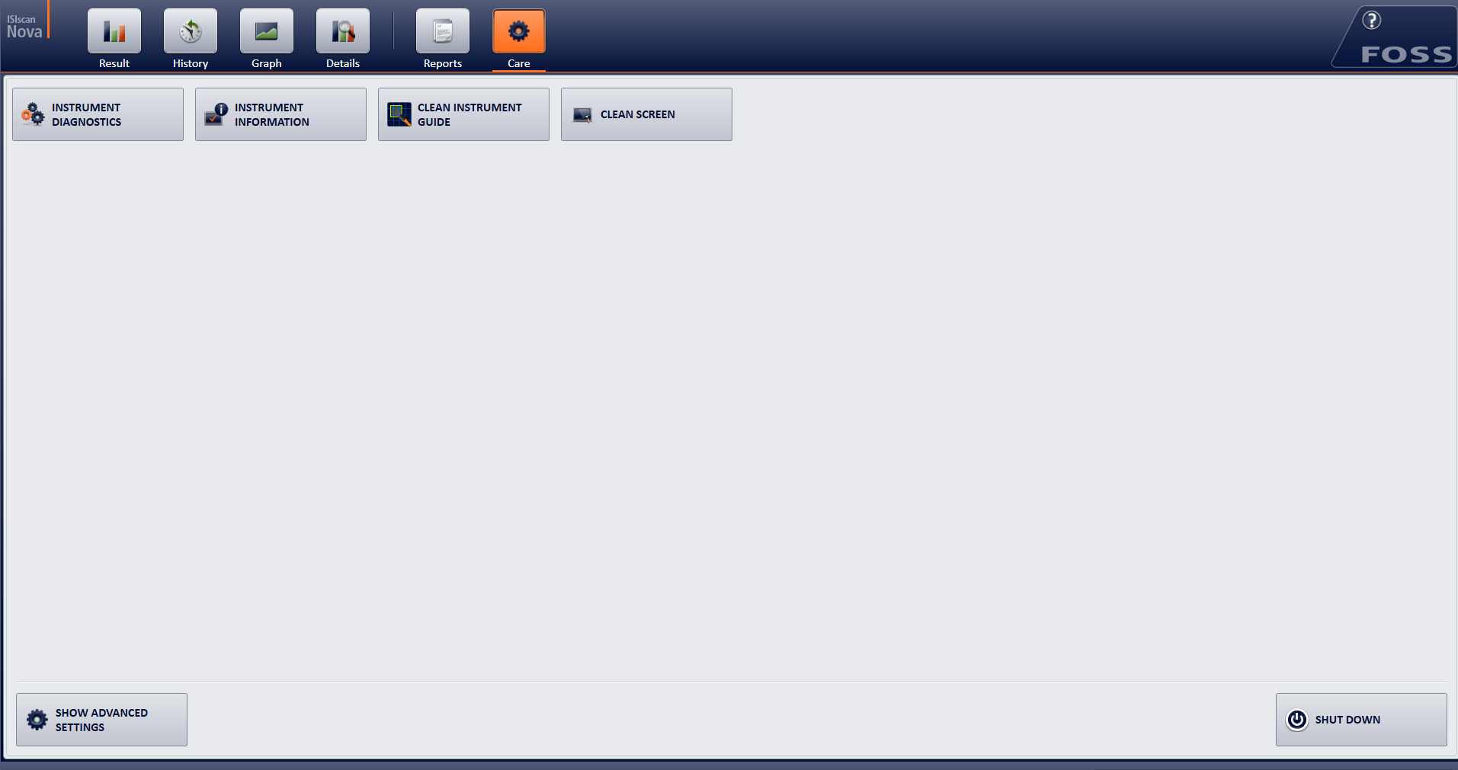
3. Select FossConnect Synchronisation (older software version “Mosaic Synchronisation”).
4. A popup box will appear
5. Select ‘Synchronise’ and it will perform a manual synchronization.

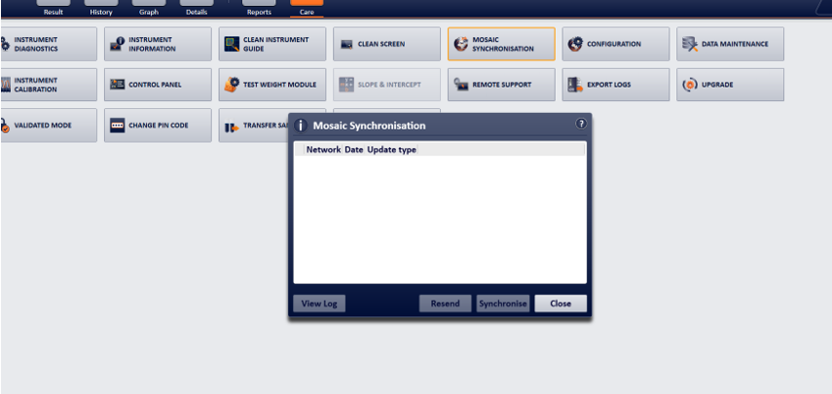

**Follow Up:** What happens next?

Once the agreed scan upload date has passed, Foss provide a list to the Grain Network of all instruments which have not uploaded. We then attempt to contact users of these instruments to find out why and encourage them to do whatever is required to get the scans to Foss.

The scans are then sent to the calibration centre for processing. At this point Foss may ask that some samples be scanned again if the scans seem unusual. The main reasons for this are usually running the samples in the wrong order, giving them the wrong file names or missing out individual samples or whole commodities. Again, we will attempt to contact users to ask for rescans. These need to be carried out quickly if the data is to be used.

Once the data is processed each instrument can be biased to match the results from the sub-masters and any calibration biases added. New calibrations are produced approximately 4 weeks after scan upload.

**Calibration Download**

You will receive an email in advance of calibration download to give you notice to connect up your instrument. You will then receive new calibrations overnight via auto-sync if enabled or you can run a manual sync as above to pick them up.

Current calibrations are listed here [**https://www.fossanalytics.com/en-gb/knowledge/ukgn**](https://www.fossanalytics.com/en-gb/knowledge/ukgn)

Once again, Foss provide a list to the Grain Network of all instruments which have not picked new calibrations up and we contact users to try and help remedy this.

Following calibration download all instruments should read within tolerance of the sub-master instrument. Performance of this instrument is monitored throughout harvest using new crop samples and if further bias corrections are required the calibration download procedure is repeated.

To ensure no gross errors have been introduced during standardisation and calibration download we run a ‘quick check’ in place of a June Ring check round to compare results before and after standardisation on the April / May ring check samples.

**Potential Problems**

1. In previous years, a small number of 1241 instruments have ‘lost’ SPW following calibration download. If this happens to your instrument a simple reboot usually corrects the problem. Please try this before contacting Foss or UKGTN about this issue.
2. Some instruments may be set up to generate automatic numbering on the samples you routinely test. If this is the case, you may have difficulty in typing in the standardisation sample ID’s. To remedy this, you will need to temporarily turn auto-numbering off as follows.

* Select Menu or Task Bar depending on instrument type.
* Enter Return.
* Enter Password 123456
* Enter Return twice
* Select 3 - Application Models
* Select 2 - Set Up
* Select 1 - Sample ID
* Select required calibrations, all must be done individually.
* Select tab to highlight ‘auto numbering’, set to ‘NO’ using up and down arrows.
* Select tab to highlight OK and press Enter.
* Repeat for each calibration required.
* On old Infratecs press left arrow repeatedly to return to main menu then press task bar
* On new Infratecs when finished just press menu key.

Once you have finished scanning the standardisation samples repeat this process, setting ‘auto-numbering’ back to ‘YES’.

1. The memory on your Infratec may fill up over time and leave no space to store the Standardisation scan data. If you are receiving messages that the memory is full, the steps below will delete existing scan and results files to make space for new data. Please make sure you export any data you require before carrying out these steps.

* Perform a manual Sync to ensure all data is saved on the server.
* Select menu or task bar depending on instrument type.
* Enter Return.
* Enter Password 123456
* Enter Return twice
* Select 4 – Scans.
* Select 2 – Delete.
* Use the tab key to highlight ‘delete all’.
* Press the enter key.
* Say yes to question ‘do you really want to delete all’.
* Select Cancel
* Select left arrow to return to operators menu.
* Select 2 – Results.
* Select 2 – Delete.
* Use the tab key to highlight ‘delete all’.
* Say yes to question ‘do you really want to delete all’.
* Select Cancel
* On old Infratecs press left arrow repeatedly to return to main menu then press task bar
* On new Infratecs when finished just press menu key.

To prevent the memory from filling up quickly – ensure that save scans is turned off after standardisation scanning is complete unless you really do want to save the scan files on all samples.

1. Some companies’ IT systems restrict data transfer by using a firewall to block communication between equipment on their network and the wider internet. This can result in communications check failures, failure to upload scans and failure to download calibration updates.

If you believe that your instrument is not communicating with the Foss server because of this, then the settings below should assist your IT department in adjusting your firewall to rectify the problem:

|  |  |
| --- | --- |
| **Infratec TM or Infratec NOVA** | |
| Host/Address | europegrain.mosaic.foss.dk |
| Port | Either one of this:   * TCP: 8014 * HTTP: 80 * HTTPS: 443 |
| **Infratec 1241** | |
| Host/Address | 13.95.153.153 |
| Port | 8012 |